**Declaration Form**

**All the below-mentioned documents are proof of details stated in my resume.**

**All the screenshots/pdfs/documents/percentage calculation sheet mentioned to be uploaded are accurate. I subject myself to disciplinary action in case of any discrepancy.**

**The documents available to upload are:**

1. **Class 10th Marksheet(along with percentage calculation sheet)**
2. **Class 12th Marksheet(along with percentage calculation sheet)**
3. **JEE Mains Result for Rank Verification**
4. **Certificate of Merit(NTSE)**
5. **Certificate of Merit(JBNSTS Scholarship examination)**
6. **Screenshot of Codeforces Handle( name: hopeless__19)**

**URL :** [**https://codeforces.com/profile/hopeless__19**](https://codeforces.com/profile/hopeless__19)

**7.Screenshot of Codeforces Round 1033( global rank 1261)**

**8. Screenshot of Educational Codeforces Round 172 ( global rank 1605)**

1. **Certificate for KVPY SA AIR 95**

**10.E-Certificate of Participation for Inter Bhawan Sports General Championship (Football).**

**11.E-Certificate of merit for 1st position in Inter Bhawan Sports Tournament(Football).**

The documents not available to upload are:

**1.Verification of project named “Underground High Voltage Transmission Lines: Efficiency , Reliability and Cost Comparision with Overhead Lines” IIT ROORKEE Electrical Department.**

**2.Verification of project named “Automated Meta Data Generation” under MARS IIT ROORKEE.(List mailed by MARS IITR TO PIC)**

**3.Verification of project named “3D pyramid hologram for 3D visualization of crystals and other crystals” (list mailed to PIC by Tinkering Lab Administration).**

**Name: Arkaprava Biswas**

**Signature:** 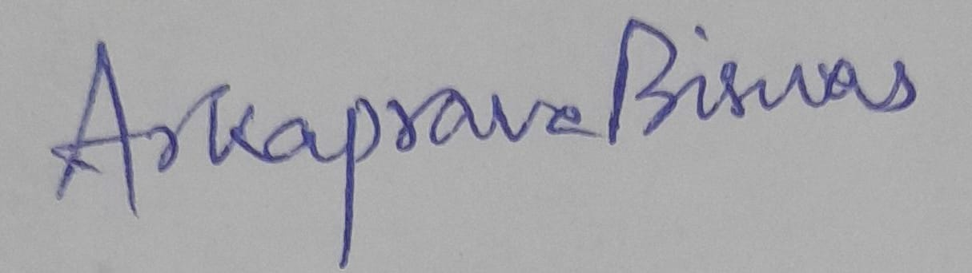

**Branch & Year: ELECTRICAL ENGINEERING ( UPCOMING 3RD YEAR)**

**Enrolment No: 23115022**

**Date: 24th June, 2025**